MACH4METAL

metalworking machinery
Transito 21
6909 DA BABBERICH Netherlands
Tel. +31 (0)316-247123
Fax: +31 (0)316-247956
info@mach4metal.com
www.mach4metal.com

Bank No : 66.52.13.883
IBAN : NL33 INGB 0665 2138 83
BIC : INGBNL2A

LVD CNC Pressbrake 320/4000 Ton
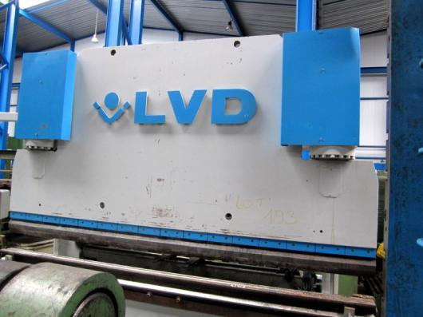

- Make : LVD - Belgium
- Typ : PPEB 320 x 4000
- No : 16631
- Age : 1990

- Max. bending length: 4.000 mm
- Between column : 3.150 mm
- Max. force : 320 Ton

- Dis. Beam – table : ca. 510 mm
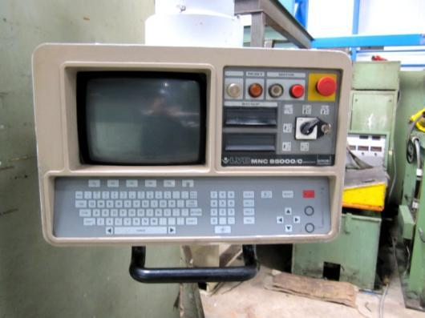
- Beam stroke : ca. 250 mm
- Depth of throath : ca. 325 mm
- Table width : ca. 250 mm

- Approch speed : 100 mm/min
- Bending speed : 8,1 mm/min
- Return speed : 55 mm/min

- CNC Control MNC 85000 / C
- Axis Y1 / Y2 / X / R - Central
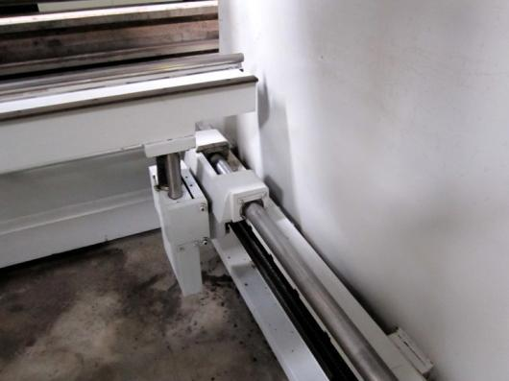

- Tools Die 150 x 150 Multi V
- Tools upper 88° Gr.

- Power 400 V / 30 kW
- Weight 25.000 Kg

- Machine is not embedded !
- Build over Floor !

Please Note: The above information has been obtained to the best of our ability and belief from, and from the manufacturers where possible. It is given in good faith, but its accuracy can not be guaranteed. Accordingly, it will not form a representation or constitute contractual terms. We advise you to check any vital details!

